Physical layer

Physical layer is where the raw bits are transmitted between the machines.

The medium through which they are transmitted can be categorized into 3 categories:-

|  |  |  |
| --- | --- | --- |
| Guided Media | Unguided media | |
| Copper wire | Wireless | Radio |
| lazers |
| Fiber optics | Satellite | |
| Magnetic Media(like DVDs) |  | |
| Twisted Pair |  | |
|  |  | |
|  |  | |
|  |  | |

.

2.1 Guided media

2.1.1

**Twisted pair**

It is one of the oldest and still the most common guided transmission media.

1. It consists of two insulated copper wires
2. 1 mm thick
3. Wires are twisted together in a helical form, just like a DNA.

**Applications**:

1. These are most commonly found the in the telephone systems.
2. They can run several kilometers without amplification, but for longer distances, a repeater is needed.
3. Twisting prevents the interference when all the cables get bundled together after coming from a telephone office apartments.
4. Due to adequate performance and low costs, twisted pairs are the most commonly and widely used cables for now and the years to come.

Two types of copper conductors can be used for twisted pair:

1)**Solid**

2) **Stranded**

**Twisted pair cable categories**

1. **UTP: Unshielded Twisted Pair**:
2. It has no internal shielding
3. It is generally used in the Ethernet Networks
4. Used for traditional telephone systems(UTP CAT-1)
5. High data transfer upto 1 Gbps
6. ***Drawback***: Vulnerable to signal interference that can effect the output quality.
7. **STP : Shielded Twisted Pair:**
8. They are internally shielded with aluminum foil.
9. Data transfer rate is 1 MBPS
10. Improve resistance to noise and interference.
11. ***Drawback***: Costly and difficult to connect at the termination points.

**Why is there twisting ?**

Twisting reduces the strength of the noise signals by moving one part of the noise in the direction of the signal and the other part in the opposite direction.

2.1.2 **Coaxial Cable**

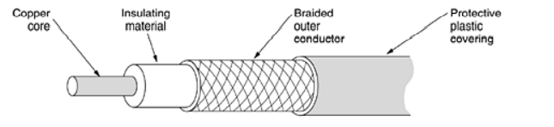

1. It’s construction gives it a High Bandwidth and an Excellent noise immunity
2. Bandwidth is close to 1 GHz.
3. Used in Cable television and Metropolitan area networks.

2.1.3 **Fiber Optics**

* Are used to carry light
* The elements inside it are coated with plastic
* Optical fibres are made of glass

**Satellites vs Fibre**

|  |  |
| --- | --- |
| Satellites | Fibre |
| Less bandwidth comparatively | More bandwidth |
| Can communicate while jogging etc. | Not possible with it |
| Broadcasting can be done | Broadcasting can’t be done |
| Cost of laying fibres is effective | Laying fibres is very expensive |
| In the poor terrestrial areas satellite is a better way for communication | Not a good way for poor terrestrial areas |
| In the military wars, communication is effective. | It losses in this aspect. |

Modems.